TABLEAU DATAVIZ CHALLENGE

TRAVEL & TOURISM.

Tableau Desktop

Tableau Desktop, largely used for business intelligence is a data visualization software that transforms huge amount of data (mostly statistical data) into interactive visual representations, such as graphs and charts.

Tableau Public

Tableau Public is a free platform to explore, create and publicly share data visualizations online. With the largest repository of data visualizations in the world to learn from, Tableau Public makes developing data skills easy. Advance your career in analytics by learning from limitless data inspiration and creating an online portfolio of work.

I have taken the datset on Tourists from foriegn countries to india classified based on their age from the open source data sets provided on Open Government Data(OGD) - data.gov.in .

Then I have created visualizations using the data.

First the geographical classification

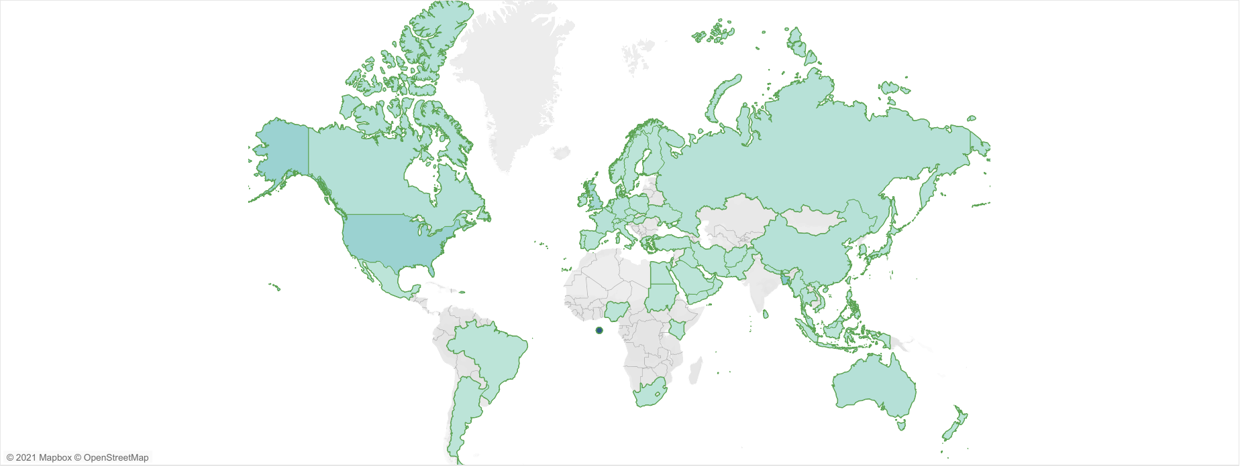

Then graphically based on regions and age groups

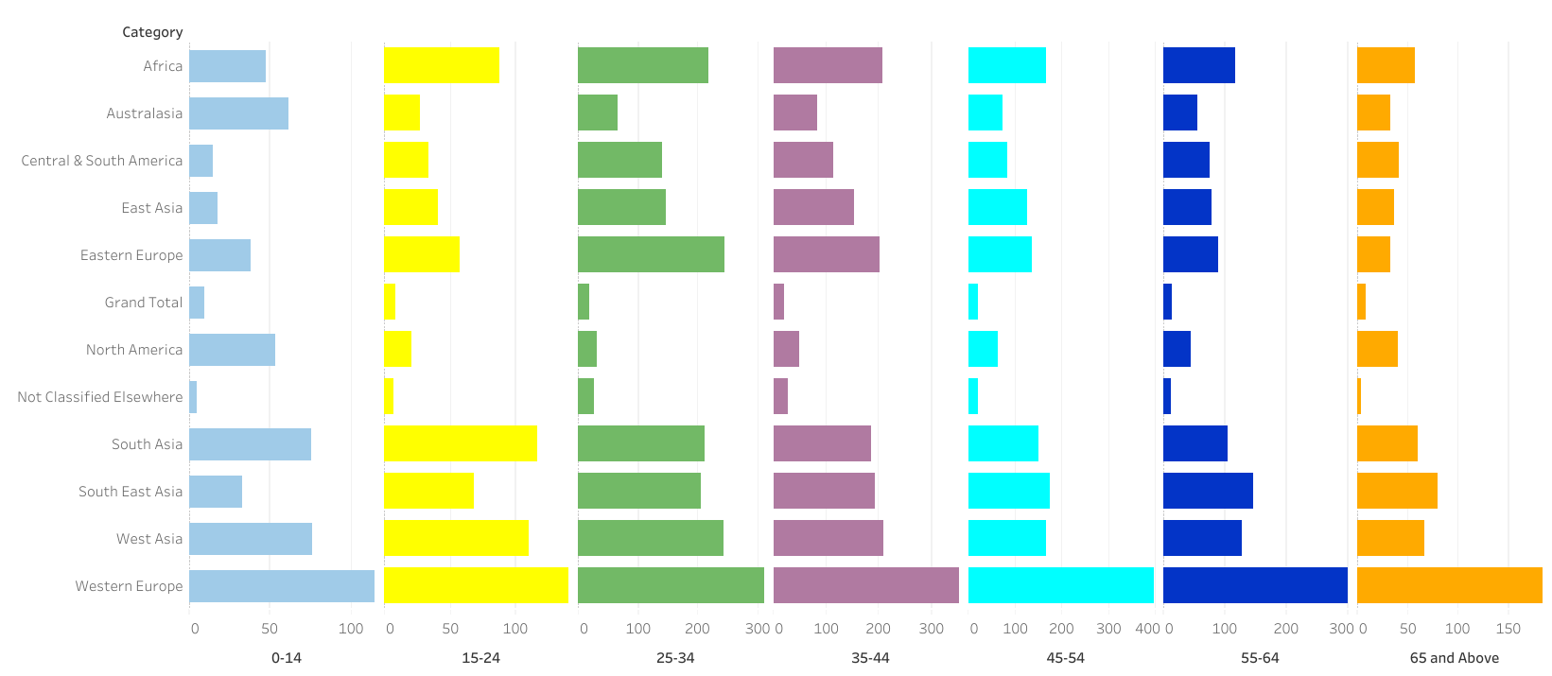

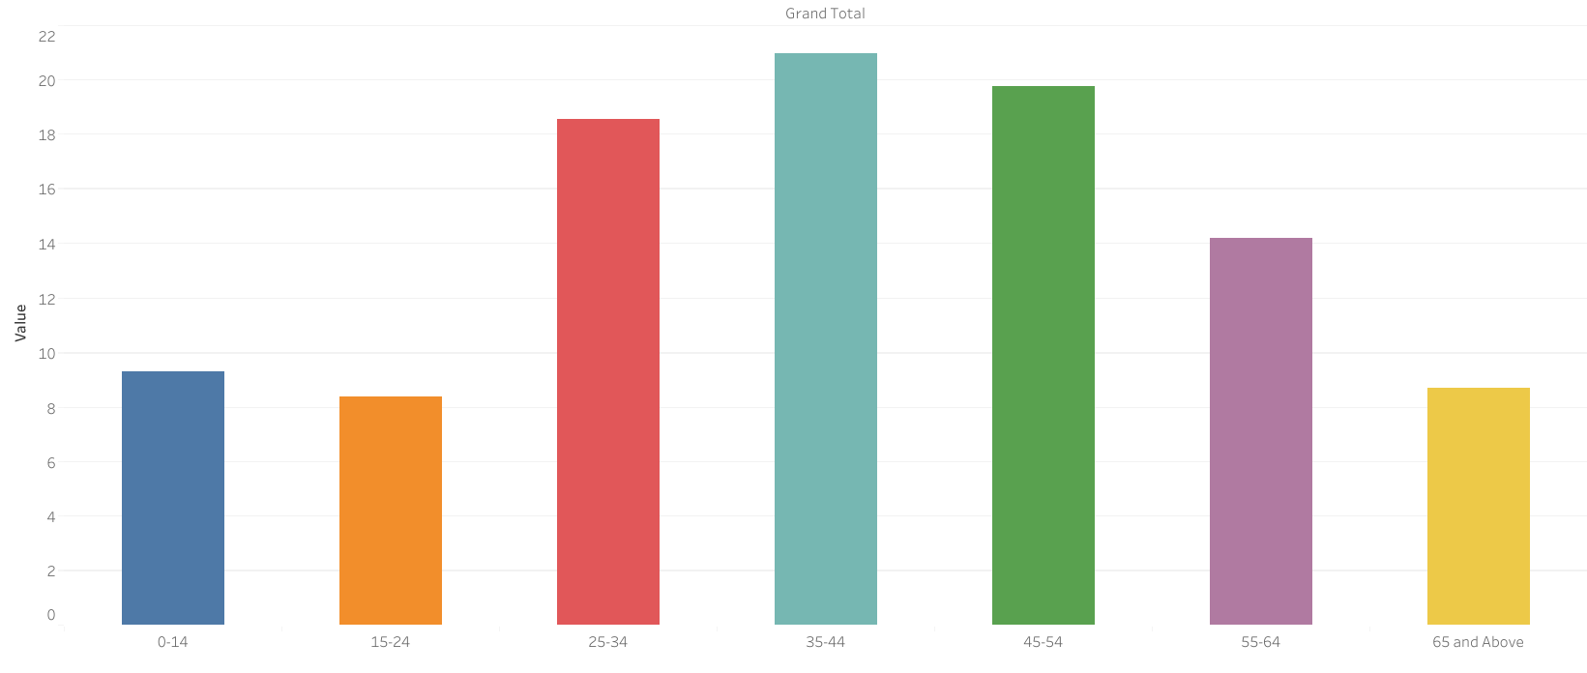

Then a dashboard to merge all these visualizations



